**Class 11 - Content: Talking on the phone**

I – Objective: Making and answering phone calls

# Warm up - Simple Plan - Welcome To My Life - <https://www.youtube.com/watch?v=hmCj7k2ZHuo>

Problem 1: you have a problem at work, and you have to make a phone call to help you to solve your problem. In pairs plan a dialogue and present it to the class considering the following or/and more information: (3,0 pontos)

1-The caller:

-say hello and your name

-state your position at work

-say what the problem is

-justify your phone call

-ask for a solution or an excuse for the problem

-finish the call

2-The receiver:

-answer the phone call and say who you are

-ask how you can help

-try to help to solve the problem

-answer and ask what is needed

-finish the call

To help you to solve the problem, you can do the activities that follow or choose your own way.

1-Watching a video: watch this video to learn vocabulary and expressions used on phone calls and write down what is necessary to do your task.

<https://www.youtube.com/watch?v=GkrEZx6Udsg>

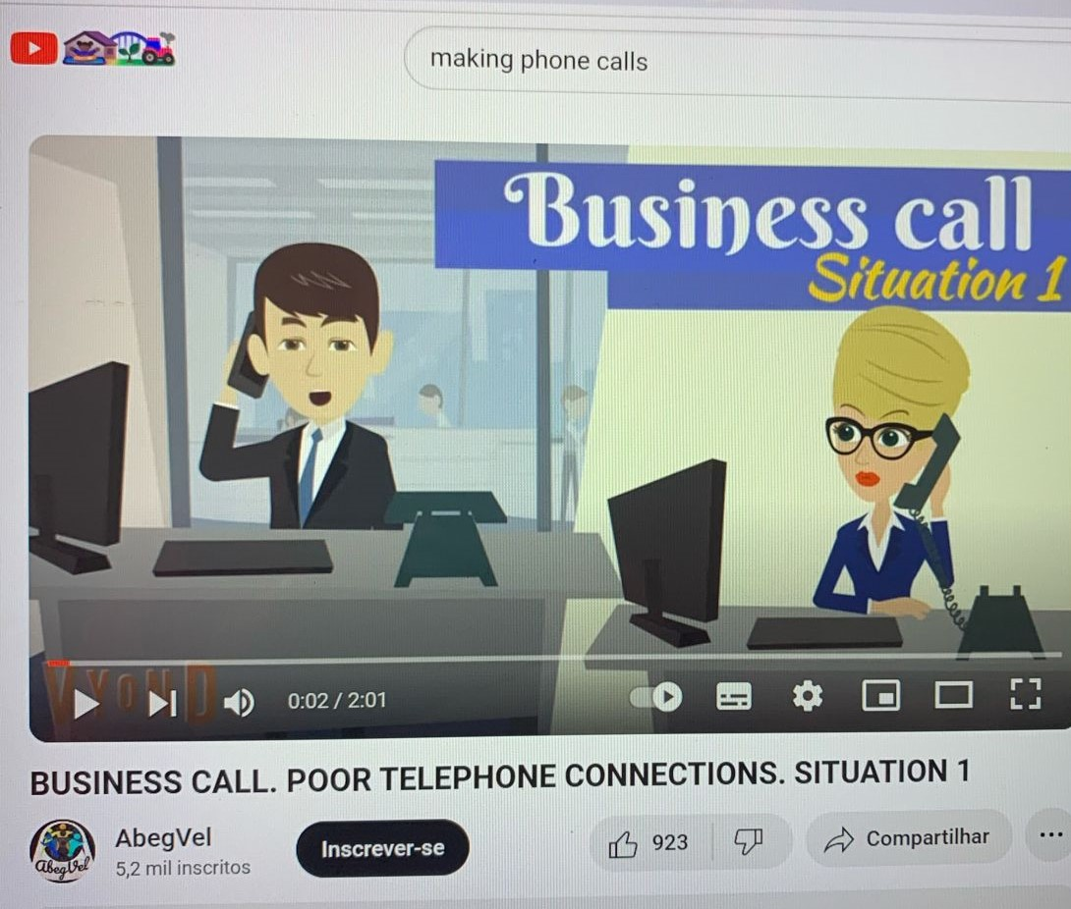

2- Vocabulary and expressions: do these exercises to improve vocabulary and after read the expressions that follows.

2.1 – Complete the sentences with the verbs from the list:

|  |
| --- |
| add enable leave lose make put recharge top up |

1 – Can I use your phone, please? I need to _________________ a call.

2 – We’re supposed to _______________ our phones on silent when we’re in class.

3 – You’ll have to _________________ data roaming if you want to make calls from abroad.

4 – Tell me your number and I’ll ________________ it to my contact list.

5 – I need to ________________ my phone because I haven’t got much credit left.

6 – Sam’s not here. Would you like to _________________ a message?

7 – My battery has run out. Where can I _____________________ my phone?

8 – This village is very remote, so you might __________________ the signal.

(from <https://english-practice.net/english-vocabulary-exercises-for-b1-on-the-phone/>)

2.2 – Replace the underlined words with the correct form of the phrasal verbs in the list

|  |
| --- |
| break up call back cut off get through to hang up  pick up run out of speak up |

**1 – I’ve been trying all day, but I can’t establish contact with the hospital.**

**_____________________________________________________________**

**2 – Sorry I didn’t answer the phone, because I was driving.**

**_____________________________________________________________**

**3 – Can you talk more loudly? I can’t hear you.**

**______________________________________________________________**

**4 – I can’t talk now, but I’ll phone again later.**

**______________________________________________________________**

**5 – I didn1t end the call until they had answered all my questions.**

**_______________________________________________________________**

**6 – Tell me if I start to become difficult to understand and I’ll go outside.**

**_______________________________________________________________**

**7 – The signa lis quite bad here, so we might get interrupted.**

**_______________________________________________________________**

**8 – You won’t be able to use your phone if you have no more credit.**

**_________________________________________________________________**

(from <https://english-practice.net/english-vocabulary-exercises-for-b1-on-the-phone/>)

**Class 12 - Content: Talking on the phone**

I – Objective: Making and answering phone calls

# Warm up – song: Yes - Owner of A Lonely Heart –<https://www.youtube.com/watch?v=YUuBCFSMYwo>

2.3 – Expressions and language used on phone calls (formal and informal).



(from <https://www.freepik.com/free-photos-vectors/phone-call>)

**1-Answering the Phone:**

**Formal:**

Hello. This is Susan. (Personal)

Hello, thank you for calling [name of company]. This is Susan – how can I help you? (Professional)

**Informal:**

Hello. Susan speaking.

**2-Greeting and introducing yourself:**

**Formal:**

This is Laure from [company name].

Hello. This is Laure. I am calling about…

**Informal:**

Hi. It’s Laure.

**3- Asking to speak to someone:**

**Formal:**

Is _____________ available?

May I speak to ________________?

I’d like to talk with _____________.

**Informal:**

Is _______ free?

Can I talk to ______?

**4- Putting someone on hold:**

**Formal:**

Can I put you on hold for a moment, please?

Would you mind holding for just a moment?

**Informal:**

Hold on a sec.

Just a sec./moment

**5- Clarifying and asking for repetition:**

**Formal:**

I’m sorry – I didn’t catch that. Could you please repeat yourself?

I’m sorry – do you mean to say………?

Would you mind speaking a little more slowly?

**Informal:**

I’m sorry. Could you repeat that?

Can you spell that?

**6- Taking a message for someone:**

**Formal:**

I’m sorry. She isn’t available at the moment. Can I take a message for her?

She is away at the moment. May I ask who is calling?

**Informal:**

I’ll let him/her know that you called.

Who’s calling, please?



(from <https://www.istockphoto.com/br/foto>)

**7- Leaving a message for someone:**

**Formal:**

Yes. Thank you. Please tell her Selma called. Ask her to call me back at……...

Please tell him I’ll be available on Thursday at 9:00.

**Informal:**

No thanks. I’ll call back later.

Yeah, tell him Selma called.

**8- Ending your call:**

**Formal:**

Thanks for calling and have a great day.

**Informal:**

I have a meeting soon so I have to/gotta run.

It was great to chat. I’ll talk to you again soon.

(adapted from: <https://www.speakconfidentenglish.com/telephone-calls-in-english/>)

2 – Listening: listen to a telephone conversation and complete the message. (Business Result Elementary by Grant, Hughes & Turner, page 22)



|  |
| --- |
| Message for: |
| From: |
| Calling about |
| Phone number: |
| Call back? ( ) Urgent? ( ) |

**Class 13 - Content: Talking on the phone**

I – Objective: Making and answering phone calls

4- Dialogue: Prepare the dialogue suggested in problem 1.

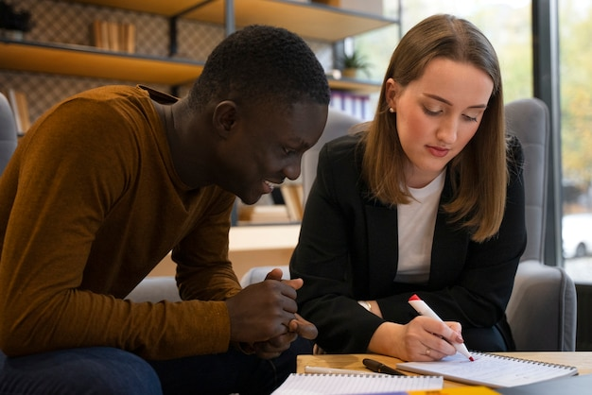

(from <https://www.freepik.com/free-photos-vectors/undergraduate-studying/2>)

**Class 14 - Content: Talking on the phone**

I – Objective: Making and answering phone calls

5- Dialogue: Presentation of the dialogue suggested in problem 1. (3,0 pontos)



(from <https://www.istockphoto.com/br/search/2/image-film?phrase=two+people+on+phone>)